
Workington Town Council
Trustee of the Borough of Workington
Workington Town Council Community Centre, Princess Street,
Workington, Cumbria, CA14 2QG.
Telephone: 01900 702986
Email: office@workingtontowncouncil.gov.uk
Website: www.workingtontowncouncil.gov.uk

29th June 2023
To Members of the Culture & Community Committee:
Cllr Ellie Wood (Chair) | Cllr David Farrar (Vice Chair)
Cllr Barbara Cannon | Cllr Susan Martin
Cllr Sue Fryer | Cllr Tricia Poole
Cllr Jackie Kirkbride | Cllr Kate Schofield
Cllr Nath Martin | Cllr Joan Wright

(Copy for information only to other members of Workington Town Council)
You are summoned to a meeting of Workington Town Council’s Culture & Community Committee on Tuesday 4th July 2023 at 7pm.
The meeting will be held at the Workington Town Council Community Centre, Princess Street, Workington, CA14 2QG.

Yours faithfully

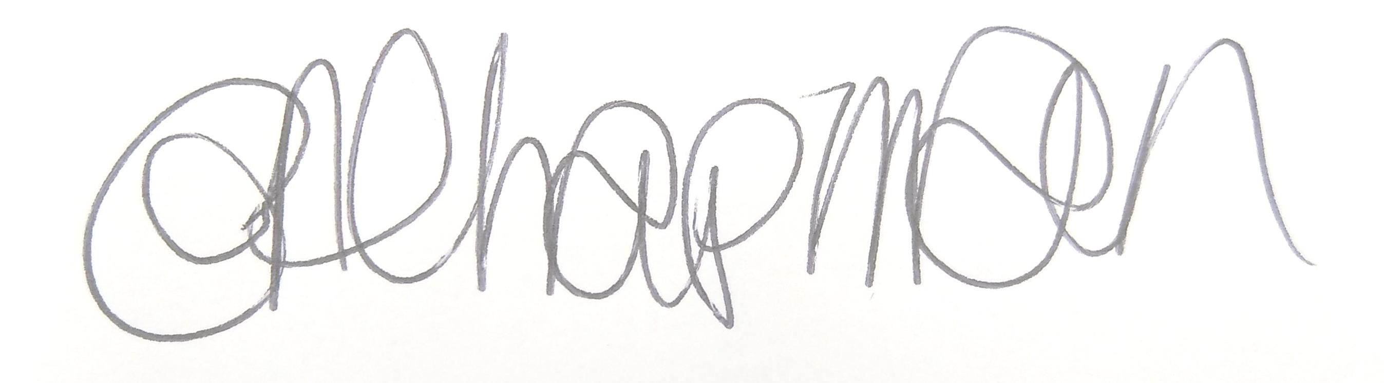

Emma Chapman
Deputy Proper Officer

AGENDA
- Apologies: To receive and note any apologies.

- Declarations of Interest: To receive any declarations of interest relating to matters on the agenda.

- Exclusion of Press and Public: To consider whether there are any agenda items during consideration of which the press and public should be excluded.

- Public Question Time: Residents are invited to give their views and question the Parish Council on issues on this agenda or raise issues for future consideration at the discretion of the Chair. This session will last no longer than 20 minutes.
- Minutes of the previous meeting: To receive the minutes from 14th June 2023 and affirm them a true record.

- Culture & Community Budget
- To review the Culture and Community budget YTD
- To review items coded to the Cultural Commissions budget line (page 9 on nominal report), that may need re-coded to Youth or Community Development.
- Committee to consider the budget line for the Summer/Sports Camp activities.

- Projects and Resolutions: Committee to note the report from officers with regards to projects and resolutions (attached as supporting document).

- Grants: To note a feedback report from Workington Zebras following receipt of a grant from WTC (attached as supporting document).

- Christmas Lights:
  - To consider a report from officers with regards to Christmas lights owned by the Council that are currently in storage (attached as supporting document).
  - To note the arrangements for the Christmas Lights for 2023 (attached as supporting document).

- Christmas Trees: To confirm locations and purchase of trees for 2023 (attached as supporting document).

- Future Plans: to consider future plans/projects/events that the committee wishes to progress for 2024. Proposals attached as supporting document.

- Cultural Commissions: To consider a list of potential organisations to benefit from the Cultural Commissions budget line. Proposals attached as supporting document.

