
Workington Town Council
Trustee of the Borough of Workington
Workington Town Council Community Centre, Princess Street,
Workington, Cumbria, CA14 2QG.
Telephone: 01900 702986
Email: office@workingtontowncouncil.gov.uk
Website: www.workingtontowncouncil.gov.uk

Date of issue: 3rd October 2023
To Members of the Environment Committee:
Cllr Michael Heaslip (Chair) | Cllr Hilary Harrington
Cllr Bernadette Jones (Vice Chair) | Cllr Allan Hodgson
Cllr Mary Bainbridge | Cllr Jackie Kirkbride
Cllr Beth Dixon | Cllr Susan Martin
Cllr Sue Fryer | Cllr Lynda Williams

(Copy for information only to other members of Workington Town Council)
You are summoned to a meeting of Workington Town Council’s Environment Committee on Wednesday 11th October at 7pm.
The meeting will be held at the Workington Town Council Community Centre, Princess Street, Workington, CA14 2QG.

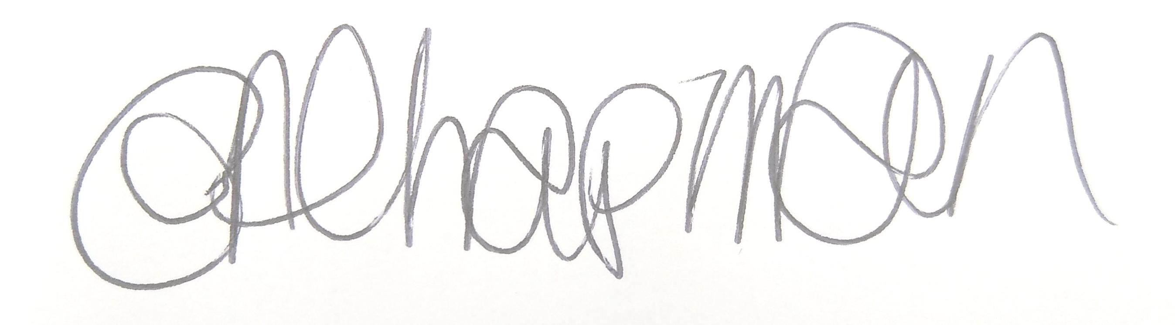

Emma Chapman
Deputy Proper Officer

AGENDA
- Apologies: To receive and note any apologies.

- Declarations of Interest: To receive any declarations of interest relating to matters which appear on this agenda.

- Exclusion of Press and Public: To consider whether there are any agenda items during consideration of which the press and public should be excluded.

- Public Participation: To consider any agenda items in which public participation will be permitted.

- Minutes of the previous meeting: To consider the minutes from the 6th July 2023 meeting and affirm them a true record.

- Public Questions: To consider any questions from electors, of which notice has been given, in accordance with Standing Order 3w.

- Questions and Statements from Members: To consider questions and statements by members of which notice has been given.

- Motions on Notice: To consider any motions from members of which notice has been given.

- Environment Budget: Committee to consider the following:
- Report for information
- Environment budget up to 22nd Sept 2023.
- Environment commitments up to 22nd Sept 2023.

- In Bloom and In Bloom Development: Committee consider the following:
- In Bloom Grant Requests
- Floral Display costs 2024
- Report for information on other matters

- Parks Development: Committee to consider the following:
- Pump Track report from Cumberland
- Report for information on other matters

- Workington Nature Partnership: Committee to note a report from WNP Officers.

- Parks Maintenance: Committee to consider the following:
- Purchase of a trailer
- Report for information on other matters

- Streetscene: Committee to note and consider any decisions required in the attached report.

- Allotments: Committee to consider the following:
- Allotment rent increase and deposit suggestion
- Report for information on other matters

