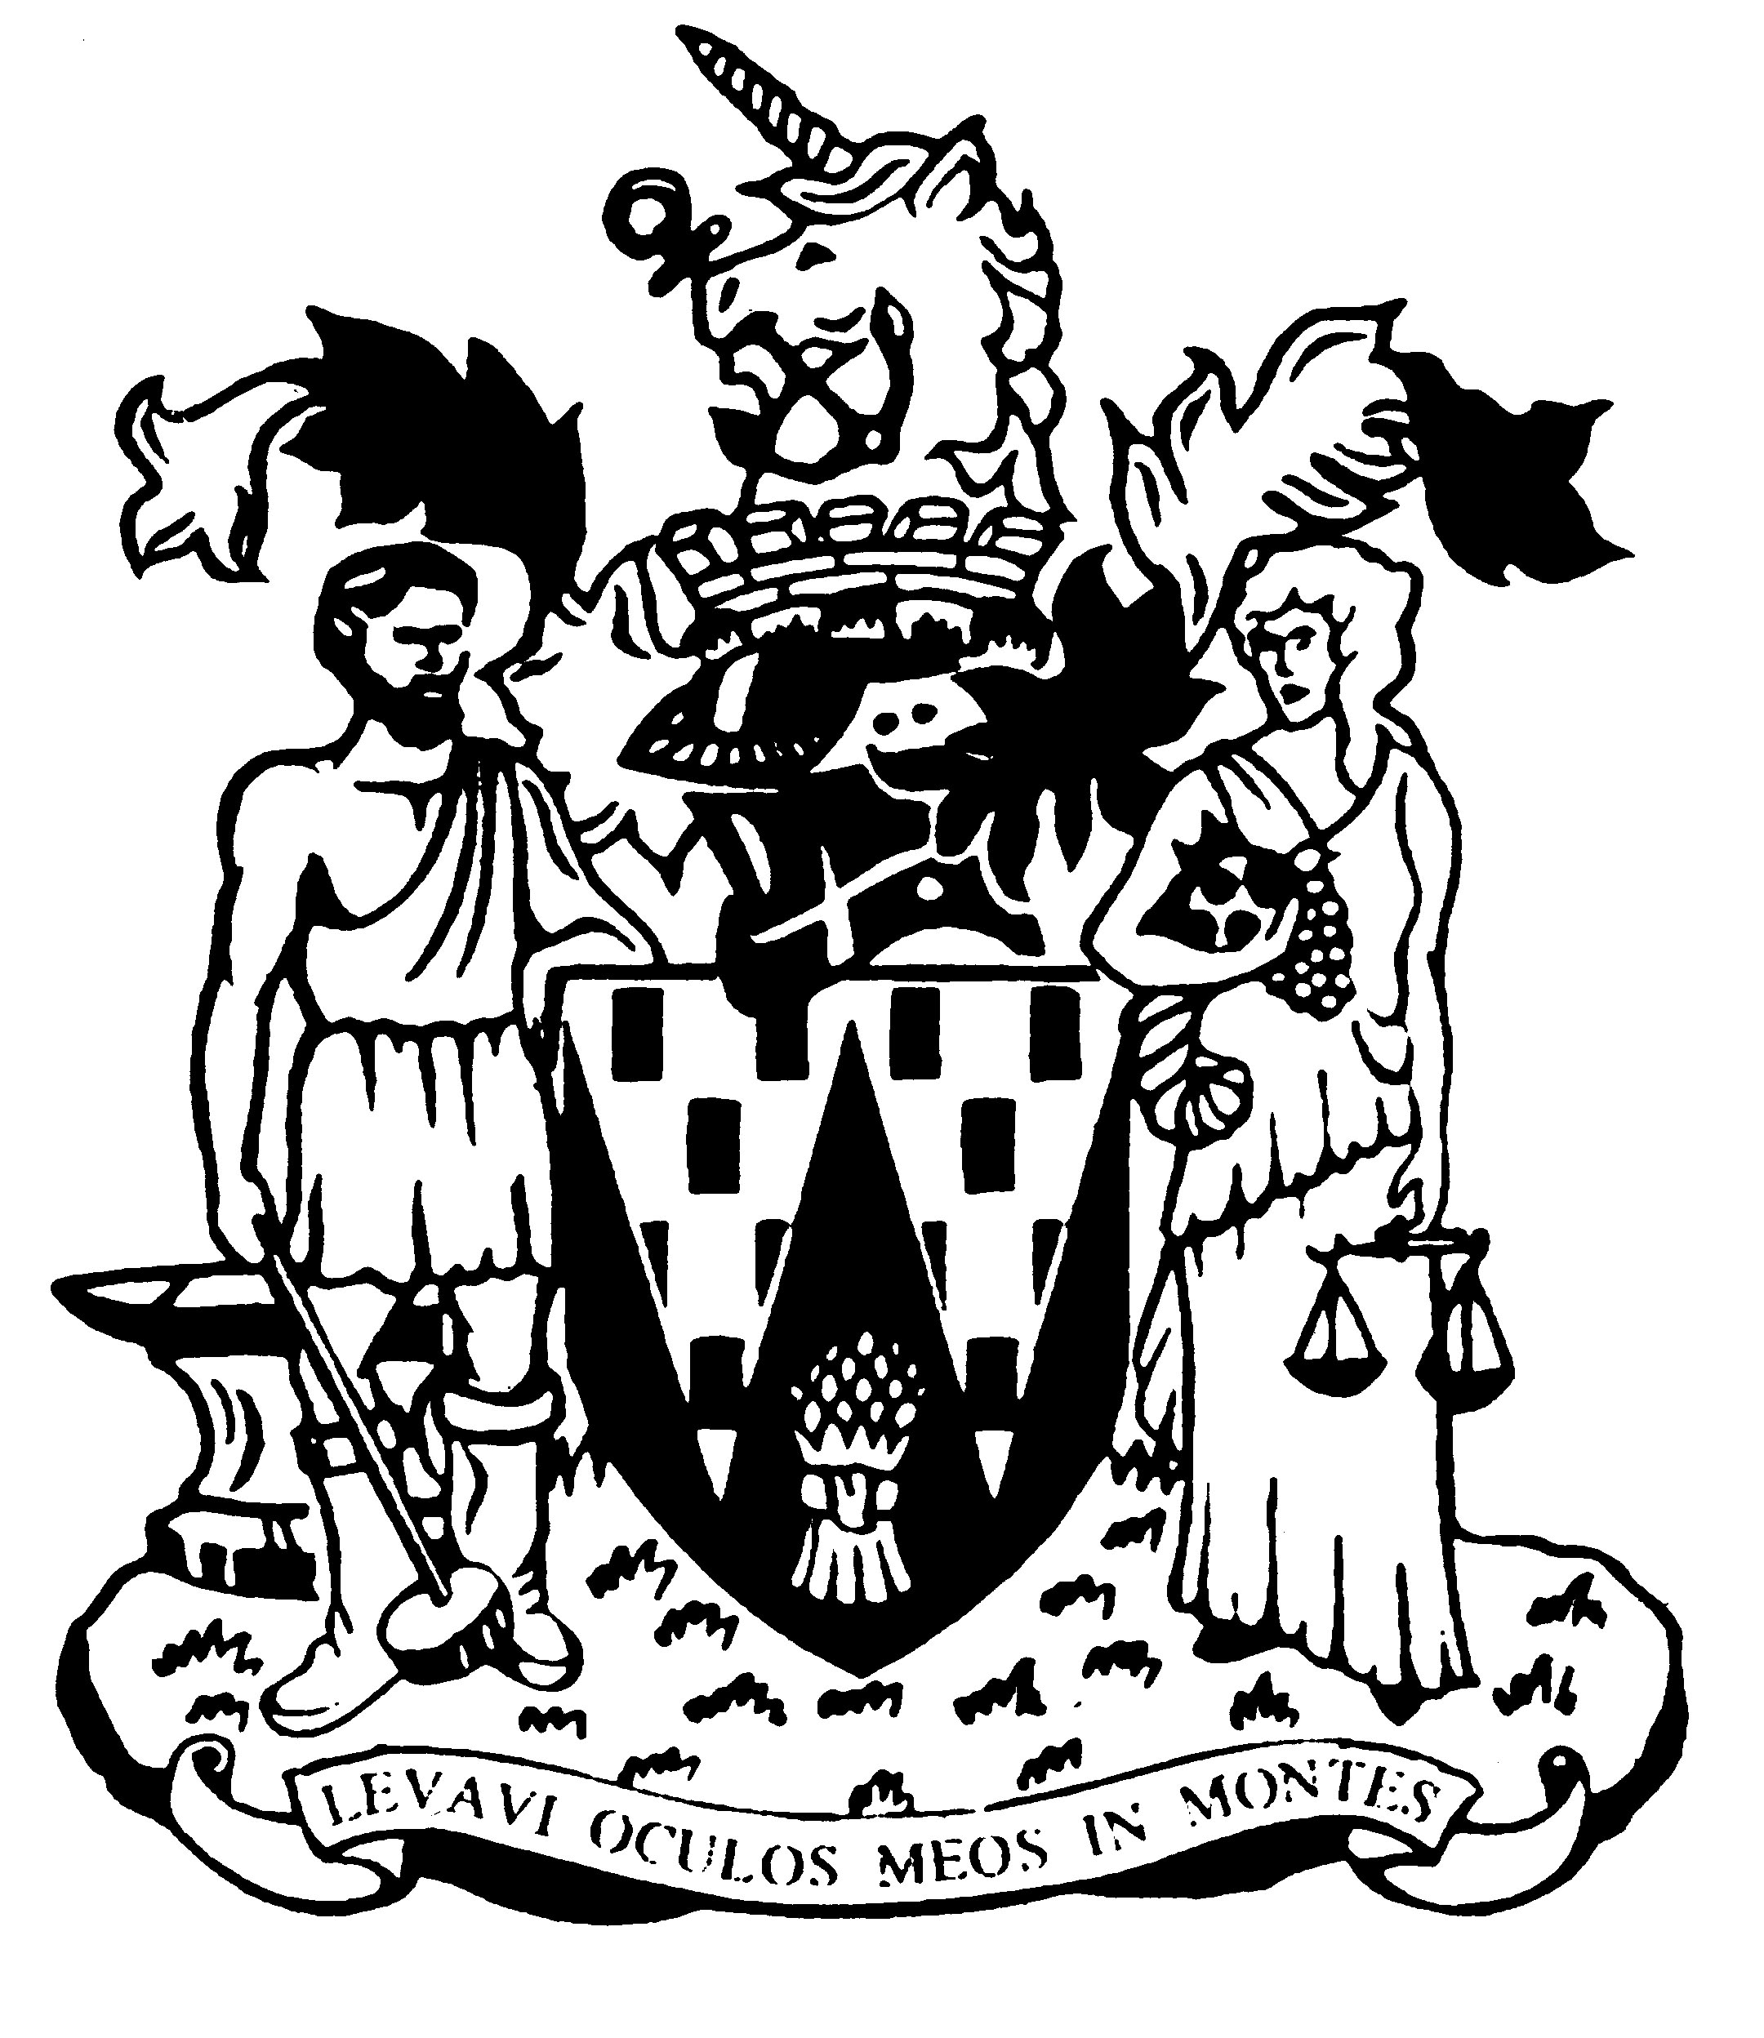

Workington Town Council

Annual Report 2024-25

For the Annual Town Meeting

Wednesday 23rd April 2025

**Councillor Neil Schofield**

**Mayor of Workington**

Workington Town Council

Membership – From May 2024-2025

|  |  |
| --- | --- |
| **Name** | **Ward** |
| Cllr Neil Schofield (Mayor) | Westfield |
| Cllr David Farrar (Deputy Mayor) | St Michaels |
|  |  |
| Cllr Hilary Harrington | Harrington |
| Cllr Paul Larkin | Harrington |
| Cllr Nath Martin | Harrington (left 11th Dec 2024) |
| Cllr Billy Miskelly | Harrington (elected 27th Feb 2025) |
| Cllr Stephen Stoddart | Moorclose |
| Cllr Lynda Williams | Moorclose |
| Cllr Joan Wright | Moorclose |
| Cllr Beth Dixon | Northside |
| Cllr Barbara Cannon | Salterbeck |
| Cllr Denise Rollo | Salterbeck |
| Cllr Ellie Wood | Salterbeck |
| Cllr Sue Fryer | St Johns |
| Cllr Michael Heaslip | St Johns |
| Cllr Susan Martin | St Johns |
| Cllr Patricia Poole | St Johns |
| Cllr Mike Rollo | St Johns |
| Cllr David Tennyson | St Johns |
| Cllr Mary Bainbridge | St Michaels |
| Cllr David Farrar | St Michaels |
| Cllr Allan Hodgson | St Michaels |
| Cllr Bernadette Jones | St Michaels |
| Cllr Mark Fryer | Stainburn |
| Cllr Jackie Kirkbride | Stainburn (left 9th Sept 2024) |
| Cllr John Mills | Stainburn (elected 25th Oct 2024) |
| Cllr Sean Melton | Westfield |
| Cllr Kate Schofield | Westfield |

Annual Report 2024-25

The Council has had a busy year and continues to work hard to enhance the lives of the people within the community.

The Environment Committee’s desire to enhance the lives of the young people in the town brought the addition of a brand-new play area in Westfield and a heavily re-developed play area at Moorclose.

New life saving defibrillators were installed at St Mary’s Church, Westfield, Northside Community Centre and Moss Bay at the Ellis Sports Ground; the town’s first solar powered defibrillator will shortly be installed at Barepot.

On the request of the committee, Officers have been streamlining allotment processes to reduce waiting lists and to ensure the Council is managing its allotment estate in the most efficient way.

The Council continues to support and develop the areas managed and maintained by Workington Nature Partnership who are dedicated to enhancing the environment in and around the town.

The Culture & Community Committee have provided funding for key organisations within the town to help improve the lives of the people in our community. The Council has also executed a busy, successful events programme which included special guest appearances in the town from 911 and Sooty, Sweep and Soo! These events are a lot of fun, but also provide essential free, family experiences, and unique opportunities that can be difficult to access for some.

The Committee’s Youth Council continues to thrive and gives the Council a much-needed insight into the thoughts and desires of the young people of the town.

The Sustainable Development Committee have successfully introduced a Climate Action Plan and commissioned several community consultations. The results give the Council a focus on actions for the future and the priorities of the town. The committee continues to be instrumental in supporting residents in their responses to local planning applications and giving feedback to the local planning authority, acting in the best interests of the community.

The Finance and General Purposes Committee have been focussing on the future and how key Council assets can be developed and better utilised. The committee has also been preparing a draft Council plan. The plan will focus the Council for the next five years and allow for sound financial planning. Community consultations will be carried out over the next coming months.

If you have any suggestions or actions for the Council, then please get in touch.

**Cllr Neil Schofield, Mayor of Workington**

An overview of the Town Council’s Accounts for the year ending 31 March 2025.

The council collected £986,709 from council taxpayers in 2024-25.

Additionally it received grant income and funding from a number of sources, which included:

* £61,200 Allerdale GDF funding for Springfield Park play area, Westfield.
* £2,000 from Washington Square Shopping Centre for the Christmas Lights and Festival.
* £1,310 from Castles and Coasts for improvements to Northside Play area.
* £400 sponsorship for the Festival of Running.

The council’s staff consists of ten posts (eight full time and two part time):

* Chief Officer/RFO
* Finance Officer/DPO
* Projects and Events Officer
* Senior Business Support
* Business Support
* Estates Team Leader
* four Estates Team members

The council also continues to fund the Workington Nature Partnership in conjunction with Cumberland Council, which supports two part time members of staff.

The council’s brief year end income and expenditure (unaudited).

|  |  |
| --- | --- |
| **Income** |  |
| Precept | **986,709** |
| Grants | **78,510** |
| Dividends | **5,372** |
| Rents and other fees | **25,589** |
| **Total** | **1,096,180** |
|  |  |
| **Expenditure** | **864,331** |

These figures are unaudited. Full audit accounts will be available for inspection by the public on 1 July 2025.

A view on the year ahead - 2025-26

The Council unanimously agreed a budget at a meeting of the Full Council on 29th January 2025.

The budget allows the Council to significantly increase community engagement and introduce local hero schemes and feedback initiatives. We would like to know what the people of our town think and want!

The Council will work on strengthening and developing the Twinning Association and Officers will be working closely with executive members to promote the work of the association and provide unique opportunities for young people in the twin towns and within our own community.

2025 is also a year of celebration as Vulcan Park will be 100 years on 4th June. The town will celebrate with a Party in the Park event on 7th June which will feature live music, fun fair, children’s activities, plus the official opening of the Council’s new Tennis Courts.

Funding is being provided by the UK Government and LTA Tennis Foundation’s Park Tennis Project, Cumberland Council and Workington Town Council to reinstate gated tennis courts. Park tennis courts are vital in providing opportunities for children and adults to get active, delivering significant physical and mental health and wellbeing benefits to participants.

The town will welcome judges from Cumbria in Bloom and RHS Britain in Bloom as finalists in these awards. Projects entered have focussed on the increase of biodiversity and wildlife in the town and new self-watering floral display mangers and baskets.

The Council is committed to developing existing play areas and open spaces and will work with the principal authority to identify areas within the town that require attention.

Investment in allotment sites is also a key area for the Council and to establish areas within the town that could be developed to allow more people to benefit from growing their own flowers, fruit and vegetables.

The Culture & Community committee have established a list of anchor organisations which provide vital services within the town and they have committed to providing support and funding to aid in the health and well-being of our people, addressing key issues that our community faces.

**We are always keen to hear the views of the community, so please get in touch.**

