WORKINGTON TOWN COUNCIL
HARRINGTON WARD

VACANCY FOR A TOWN COUNCILLOR

LOCAL GOVERNMENT ACT 1972 (SECTION 87(2))
THE LOCAL ELECTIONS (PARISHES AND COMMUNITIES) (AMENDMENT) RULES 1986 (RULE 8 (1))

- There is a vacancy on the above-mentioned Council following the resignation of Councillor Nathan Martin.

- A by-election to fill the vacancy must be held if, within 14 working days* from the date of the publication of this Notice, ten electors for the Parish (or Parish Ward) give notice, in writing requesting such an election to the Returning Officer.

- The address of the Returning Officer is:
Returning Officer
Cumberland Council
Civic Centre
Carlisle
CA3 8QG

- If no such notice is given, the Town Council must fill the vacancy by co-option as soon as practicable after the period of 14 days.

Dated: 13.12.2024
Signed: 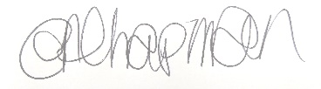

Workington Town Council
Town Hall
Oxford Street
Workington
CA14 2RS

*Working days exclude Saturdays, Sundays and Bank Holidays

