
Workington Town Council
Town Hall, Oxford Street, Workington, CA14 2RS
Telephone: 01900 702986
Email: office@workingtontowncouncil.gov.uk
Website: www.workingtontowncouncil.gov.uk

Date of issue: Tuesday 28th January 2025
To Members of the Culture & Community Committee:
Cllr Ellie Wood (Chair) | Cllr Susan Martin (Vice Chair)
Cllr Beth Dixon | Cllr Paul Larkin
Cllr David Farrar | Cllr Tricia Poole
Cllr Sue Fryer | Cllr Stephen Stoddart
Cllr Allan Hodgson | Cllr Joan Wright

(Copy for information only to other members of Workington Town Council).
You are summoned to a meeting of Workington Town Council’s Culture & Community Committee on Tuesday 4th February 2025 at 6.30pm.
The meeting will be held at the Workington Town Council Offices, Town Hall, Oxford Street, Workington, CA14 2RS.

Yours sincerely,
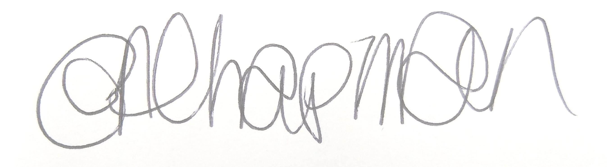

Emma Chapman
Chief Officer/RFO

AGENDA
- Absences: To note any absences.

- Declarations of Interest: To receive any declarations of interest relating to matters on the agenda.

- Exclusion of Press and Public: To consider whether there are any agenda items during consideration of which the press and public should be excluded.

- Public Participation: To consider any agenda items in which public participation will be permitted.

- Minutes of previous meetings: To approve the minutes of 29th October 2024 and affirm them a true record.

- Public Questions: To consider any questions from electors, of which notice has been given.

- Questions and Statements from Members: To consider questions and statements by members of which notice has been given.

- Motions on Notice: To consider any motions from members of which notice has been given.

- Budget 2024-2025: To note the budget monitoring report YTD.

- Workington Gateway: Creative Conversations: Committee to note the report for information.

- Funding/commission feedback: To note feedback from the following organisations.
- St Mary’s PCC
- WADAMS
- Workington Heritage Group Ltd

- Funding/commission support: Committee to note the following funding/commissions approved by the Chair and Vice Chair in between meetings.
- £550 funding to STAR to host a Christmas event for the local community from the youth and community budget line.
- £600 funding to West Cumbria Search and Rescue for general running costs to support the services they provide to the town from the youth and community work budget line.

- New funding/commission/partnership requests:
- To consider an application from Autism Support Allerdale and Copeland
- To consider an application from Workington Bowling Club
- To consider an application from Over The Rainbow CIC
- To consider an application from Cumbria Community Foundation

- Youth Council report: Committee to note the report for information.

- Events Programme 2025: Committee to receive an update on the events programme for 2025.

