
Workington Town Council
Trustee of the Borough of Workington
Workington Town Council Community Centre, Princess Street,
Workington, Cumbria, CA14 2QG.
Telephone: 01900 702986
Email: office@workingtontowncouncil.gov.uk
Website: www.workingtontowncouncil.gov.uk

Date of issue: 30th October 2023

To Members of Development Committee:

Cllr Sean Melton (Chair) | Cllr Allan Hodgson (Vice Chair)
Cllr David Farrar | Cllr Tricia Poole
Cllr Hilary Harrington | Cllr Kate Schofield
Cllr Paul Larkin | Cllr Neil Schofield
Cllr Nath Martin | Cllr Dave Tennyson

(Copy for information only to other members of Workington Town Council)
You are summoned to a meeting of Workington Town Council’s Development Committee on Monday 6th November at 7pm.
The meeting will be held at the Workington Town Council Community Centre, Princess Street, Workington, CA14 2QG.

Yours sincerely,
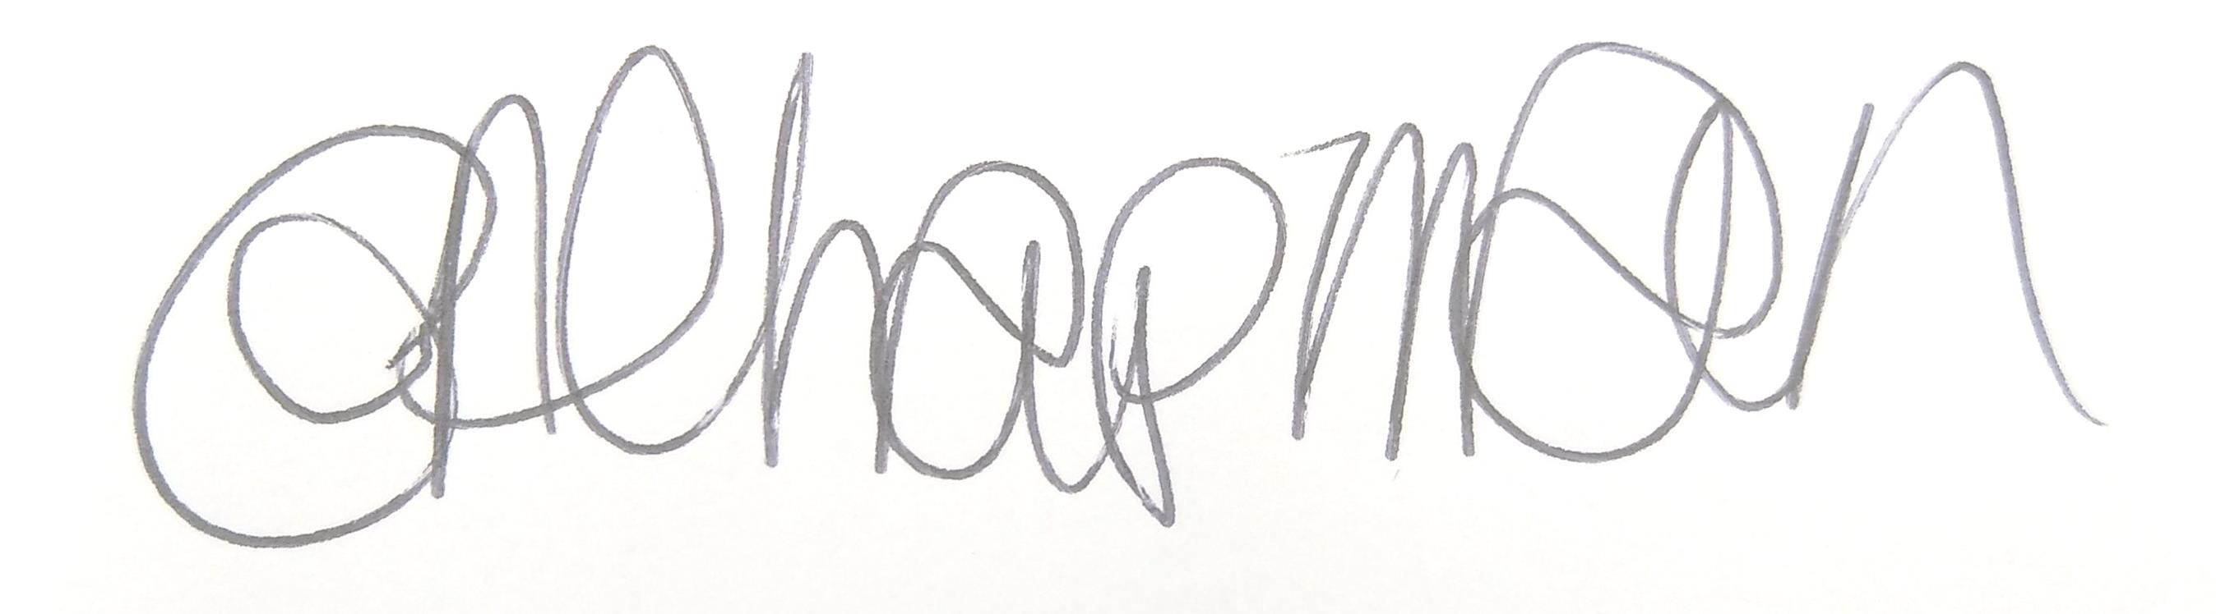

Emma Chapman
Deputy Proper Officer

AGENDA

- Apologies: To receive and note any apologies.

- Declarations of Interest: To receive any declarations of interest relating to matters which appear on this agenda.

- Exclusion of Press and Public: To consider any agenda items of which the press and public should be excluded.

- Public Participation: To consider any agenda items in which public participation will be permitted.

- Minutes of previous meetings: To approve the minutes of 9th October 2023 and affirm them a true record.

- Public Questions: To consider any questions from electors, of which notice has been given in accordance with Standing Order 3w.

- Questions and Statements from Members: To consider questions and statements by members of which notice has been given.

- Motions on Notice: To consider any motions from members of which notice has been given.

- Planning Applications: To consider the following planning applications received from Cumberland Council.

The committee will consider planning applications received and published by local planning authorities up to the date of the meeting. Where the publication of the application is after the initial publication of the agenda, items will be added up to the day of the meeting. A full list of applications likely to be considered can be obtained by checking the local planning authority website - https://cumberlandcouncil.my.site.com/pr3/s/register-view?c__r=Arcus_BE_Public_Register

No. | Reference No. | Address | Description | Deadline for comment
A | HOU/2023/0166 | 19 East Avenue, High Harrington, Workington,  CA14 5PJ | Single storey extension. | 09/11/2023
B | FUL/2022/0150 | Store & Premises, Harbour Side Chandlers, Stanley Street, Workington, CA14 2JD | Re-submission of application FUL/2022/0150 for the Change of Use of commercial premises to a domestic house, including demolition of existing garage and building of two storey side extension. | 09/11/2023
C | FUL/2023/0218 | Sphera Antiques & Militaria, King Street, Workington,  CA14 4DL | Change of use from public house and managers flats at first floor to café. | 09/11/2023
D | FUL/2023/0223 | Land opposite Cumbria Hand Car Wash, Park Lane, Workington,  CA14 2AL | Retrospective application for the siting of a new cabinet structure known as a VDSL Sidepod Cabinet. | 14/11/2023
E | FUL/2023/0220 | 1, 2 and 3 Kerry Park Trading Estate, Workington, CA14 3TX | Proposed extension to front of existing dental practice. | 20/11/2023
F | ADV/2023/0013 | 3-9 Risman Place, Workington, CA14 3DU | Advertisement consent for proposed new illuminated fascia signage in shopfront window. | 20/11/2023
G | FUL/2023/0227 | 9 Brow Top, Workington, CA14 2DP | Change of use from dwelling to funeral parlour. | 24/11/2023

- Previous Application Responses
Committee to note the outcome of previous applications:

No. | Reference No. | Address | Description | Outcome
A | FUL/2023/0194 | Our Lady and St Michaels Church, Banklands, Workington CA14 3EP | Proposal for a new entrance, level access path and Narthex improvements | Granted
B | HOU/2023/0148 | 29 Stainburn Road, Stainburn, CA14 1SW | Proposed single storey rear extension replacing existing conservatory and utility/outhouses | Granted
C | FUL/2023/0115 | Former Social Club Site, Cranbourne/Cross Street, Workington | Erection of 5 no. two bed houses and 2 no. 4 bed houses; new site access and associated external works. | Granted
D | FUL/2023/0122 | Central Car Park, Workington, CA14 3BG | Proposal of a new Community Diagnostics Hub | Granted

- Invitations to Speak
Committee to consider if they wish to accept invitations to attend the following meetings from Cumberland Council to with regards to the below planning applications.

No. | Reference No. | Address | Description | Meeting
A | FUL/2023/0176 | The Former Henry Curwen Public House and the A66/A596 junction, Workington, Cumbria | Demolition of the former Henry Curwen public house and reinstatement works at Ramsay Brow to enable the widening of the A66/A595 junction | 8th Nov at 10.30 am in the Civic Centre, Carlisle
B | FUL/2023/0071 | Site adjacent to Garth Road, Westfield, Workington, CA14 5AQ | Erection of 5 two bed bungalows, new site access and associated external works. | 8th Nov at 10.30 am in the Civic Centre, Carlisle

