
Workington Town Council
Town Hall, Oxford Street, Workington, CA14 2RS
Telephone: 01900 702986
Email: office@workingtontowncouncil.gov.uk
Website: www.workingtontowncouncil.gov.uk

Date of issue: Tuesday 5th November 2024 v2
To Members of the Environment Committee:
Cllr Michael Heaslip (Chair) | Cllr Bernadette Jones (Vice Chair)
Cllr Mary Bainbridge | Cllr Nath Martin
Cllr Beth Dixon | Cllr Susan Martin
Cllr Sue Fryer | Cllr Sean Melton
Cllr Hilary Harrington

(Copy for information only to other members of Workington Town Council)
You are summoned to a meeting of Workington Town Council’s Environment Committee on Thursday 7th November 2024 at 6.30pm.
The meeting will be held at the Workington Town Council Offices, Town Hall, Oxford Street, Workington, CA14 2RS.

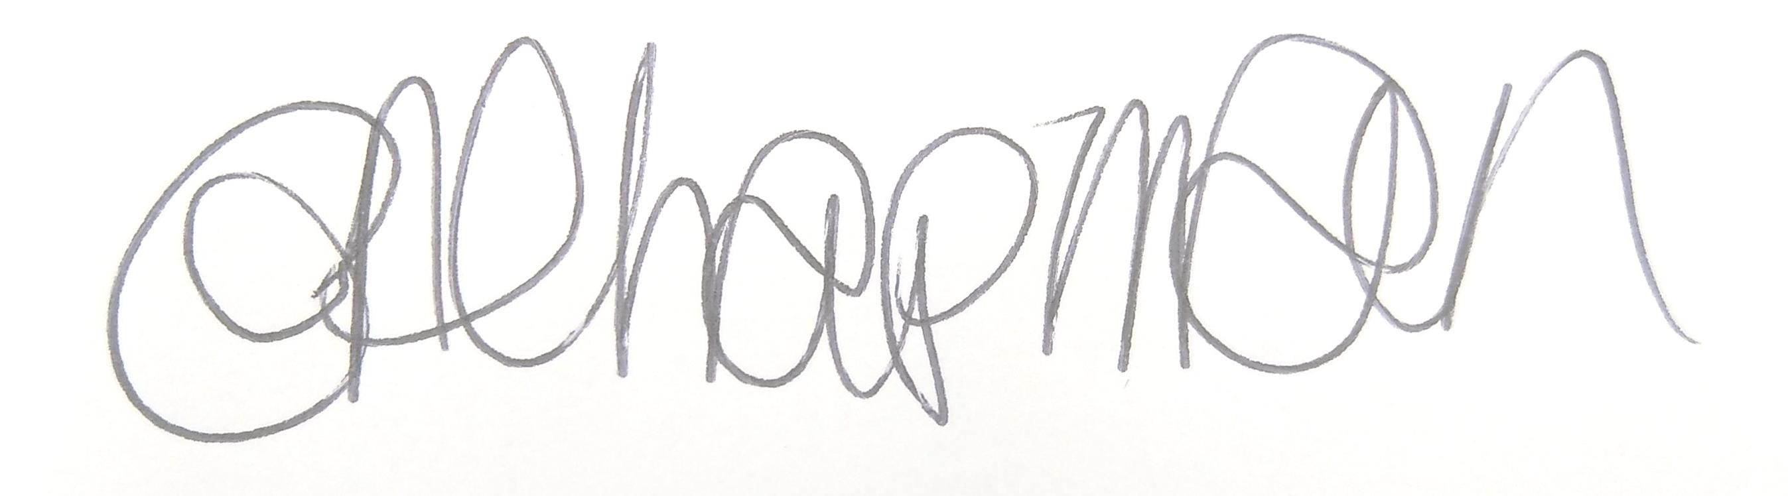

Emma Chapman
Chief Officer/RFO

AGENDA
- Absences: To note any absences.

- Declarations of Interest: To receive any declarations of interest relating to matters which appear on this agenda.

- Exclusion of Press and Public: To consider whether there are any agenda items during consideration of which the press and public should be excluded.

- Public Participation: To consider any agenda items in which public participation will be permitted.

- Minutes of the previous meeting: To consider the minutes from the 19th September 2024 meeting and affirm them a true record.

- Public Questions: To consider any questions from electors, of which notice has been given.

- Questions and Statements from Members: To consider questions and statements by members of which notice has been given.

- Motions on Notice: To consider any motions from members of which notice has been given.

- Budget 2024-2025: To review the budget YTD and estimated spend to 31st March 2025.

- Street Displays: Committee to note the report for information.

- Environmental Activities: Committee to note the report on the following for information.
a. Cumbria in Bloom award and feedback
b. Environmental activities annual calendar
c. 100 years of Vulcan Park ideas

- Green Grants: To consider applications for funding from the below organisation.
a. St Patrick's Catholic Primary School

- Streetscene:
To note reports on the following for information:
a. Public rights of way
b. Police update (see newsletter)
c. Christmas trees

To consider a funding request from the below organisation.
d. Workington RFC (Zebras) funding request

Committee to consider and approve the below agreement:
e. Defib agreement

- Estate Development: Committee to note report on the following for information.
  - Play area update
  - Funding opportunity with the Lawn Tennis Association

- Allotments: To note the report and make any decisions required.

- Workington Nature Partnership: To note the minutes from the Steering Group meeting held on 3rd October 2024.

- Budget 2025-2026: Committee to consider the draft budget for 2025-2026.

