
Workington Town Council
Town Hall, Oxford Street, Workington, CA14 2RS
Telephone: 01900 702986
Email: office@workingtontowncouncil.gov.uk
Website: www.workingtontowncouncil.gov.uk

Date of issue: Tuesday 10th September 2024.
To Members of the Culture & Community Committee:
Cllr Ellie Wood (Chair) | Cllr Susan Martin (Vice Chair)
Cllr Beth Dixon | Cllr Paul Larkin
Cllr David Farrar | Cllr Tricia Poole
Cllr Sue Fryer | Cllr Stephen Stoddart
Cllr Allan Hodgson | Cllr Joan Wright

(Copy for information only to other members of Workington Town Council).
You are summoned to a meeting of Workington Town Council’s Culture & Community Committee on Tuesday 17th September 2024 at 6.30pm.
The meeting will be held at the Workington Town Council Offices, Town Hall, Oxford Street, Workington, CA14 2QG.

Yours sincerely,
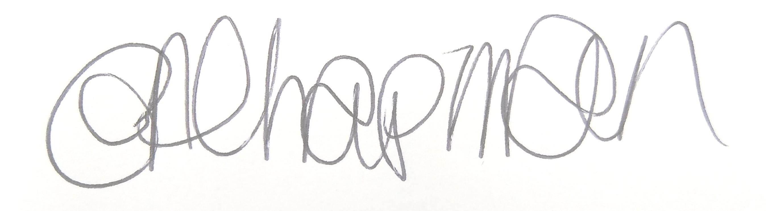

Emma Chapman
Chief Officer/RFO

AGENDA
- Absences: To note any absences.

- Declarations of Interest: To receive any declarations of interest relating to matters on the agenda.

- Exclusion of Press and Public: To consider whether there are any agenda items during consideration of which the press and public should be excluded.

- Public Participation: To consider any agenda items in which public participation will be permitted.

- Minutes of previous meetings:
- To approve the minutes of 28th May 2024 and affirm them a true record.
- To approve the minutes of 2nd July 2024 and affirm them a true record.

- Public Questions: To consider any questions from electors, of which notice has been given in accordance with Standing Order 3w.

- Questions and Statements from Members: To consider questions and statements by members of which notice has been given.

- Motions on Notice: To consider any motions from members of which notice has been given.

- Budget: To note the budget monitoring report YTD.

- Youth and Community work: Committee to note the report for information and make any decisions required.

- Funding/commission feedback: To note feedback from the following organisations.
- Carnegie Singers
- Carnegie Theatre and Arts Centre
- Christmas in Company
- Northside Primary School
- Workington Heritage Group
- Workington RFC Finches

- New funding/commission/partnership requests:
- To consider an application from Carnegie Singers
- To consider an application from Team Evie – Santa Dash

- Events Programme 2025: Committee to consider the draft events programme and event budget for 2025.

