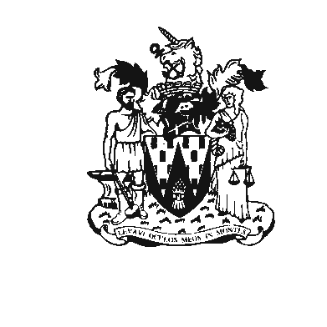
Workington Town Council
Workington Town Council Community Centre, Princess Street,
Workington, Cumbria CA14 2QG.
Telephone: 01900 702986
Email: office@workingtontowncouncil.gov.uk
Website: www.workingtontowncouncil.gov.uk

13th December 2022

Dear Councillor

You are summoned to an extraordinary meeting of Workington Town Council on Monday 19th December 2022 at 7pm. The meeting will take place at the WTC Community Centre, Princess Street, Workington.

Yours faithfully

CGourlay

Catherine Gourlay
Town Clerk

AGENDA

Public Participation
To discuss any items of interest to the council brought forward by members of the public. This session will last no longer than 20 minutes. The council cannot take any decisions in this session, except to bring items to a future meeting. The public are not permitted to speak in other parts of the meeting unless allowed to do so by the chairman.

1. Apologies
To receive and note any apologies.

2. Declarations of Interest
To receive any declarations of interest relating to matters which appear on this agenda, but which have not been previously declared on members’ declarations of pecuniary interest and other interests.

3. Exclusion of Press and Public (Public Bodies Admission to Meetings Act 1960)
To consider whether there are any agenda items during consideration of which the press and public should be excluded.

4. Minutes of the previous meeting
The minutes of the 30th November 2022 will be available at the next Full Council meeting on the 18th January 2023.
PART TWO

5. Moss Bay Development
To receive a verbal update.

