
Workington Town Council
Trustee of the Borough of Workington
Workington Town Council Community Centre, Princess Street,
Workington, Cumbria, CA14 2QG.
Telephone: 01900 702986
Email: office@workingtontowncouncil.gov.uk
Website: www.workingtontowncouncil.gov.uk

Date of issue: 27th February 2024
To Members of the Culture & Community Committee:
Cllr Ellie Wood (Chair) | Cllr David Farrar (Vice Chair)
Cllr Barbara Cannon | Cllr Susan Martin
Cllr Sue Fryer | Cllr Tricia Poole
Cllr Jackie Kirkbride | Cllr Kate Schofield
Cllr Nath Martin | Cllr Joan Wright

(Copy for information only to other members of Workington Town Council).
You are summoned to a meeting of Workington Town Council’s Culture & Community Committee on Tuesday 5th March 2024 at 7pm.
The meeting will be held at the Workington Town Council Community Centre, Princess Street, Workington, CA14 2QG.

Yours sincerely,
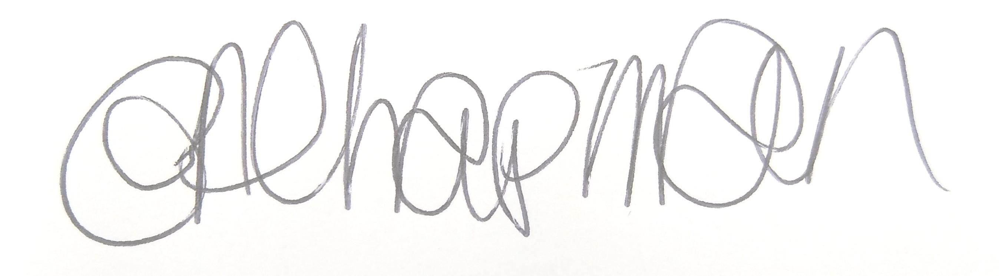

Emma Chapman
Deputy Proper Officer

AGENDA
- Apologies: To receive and note any apologies.

- Declarations of Interest: To receive any declarations of interest relating to matters on the agenda.

- Exclusion of Press and Public: To consider whether there are any agenda items during consideration of which the press and public should be excluded.

- Public Participation: To consider any agenda items in which public participation will be permitted.

- Minutes of previous meetings: To approve the minutes of 6th February 2024 and affirm them a true record.

- Public Questions: To consider any questions from electors, of which notice has been given in accordance with Standing Order 3w.

- Questions and Statements from Members: To consider questions and statements by members of which notice has been given.

- Motions on Notice: To consider any motions from members of which notice has been given.

- Twinning Presentation: To receive a presentation from the Twinning Association.

- Budget: To note the budget monitoring report.

- Cultural Commissions Policy: To consider and approve a new Cultural Commissions policy.

- Youth & Community Work policy: To consider and approve a new Youth and Community policy.

- Christmas Lights: To note the report and make any decisions required.

- Previous applications for funding/commission requests:
- To consider an application from New Hope CIC
- To consider an application from Workington Heritage Group

- New funding/commission requests:
- To consider an application from Cumberland Council
- To consider an application from the Rotary

- Events programme/budget 2024-2025: To note the report.

- Schools Competition: To note the report.

- Art Competition: To note the report.

