
Workington Town Council
Town Hall, Oxford Street, Workington, CA14 2RS
Telephone: 01900 702986
Email: office@workingtontowncouncil.gov.uk
Website: www.workingtontowncouncil.gov.uk

Date of issue: Thursday 12th September 2024
To Members of the Environment Committee:
Cllr Michael Heaslip (Chair) | Cllr Bernadette Jones (Vice Chair)
Cllr Mary Bainbridge | Cllr Nath Martin
Cllr Beth Dixon | Cllr Susan Martin
Cllr Sue Fryer | Cllr Sean Melton
Cllr Hilary Harrington

(Copy for information only to other members of Workington Town Council)
You are summoned to a meeting of Workington Town Council’s Environment Committee on Thursday 19th September 2024 at 6.30pm.
The meeting will be held at the Workington Town Council Offices, Town Hall, Oxford Street, Workington, CA14 2RS.

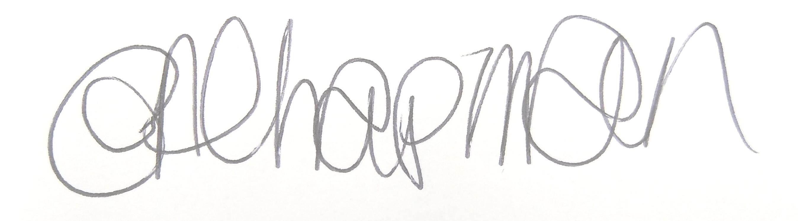

Emma Chapman
Chief Officer/RFO

AGENDA
- Absences: To note any absences.

- Declarations of Interest: To receive any declarations of interest relating to matters which appear on this agenda.

- Exclusion of Press and Public: To consider whether there are any agenda items during consideration of which the press and public should be excluded.

- Public Participation: To consider any agenda items in which public participation will be permitted.

- Minutes of the previous meeting: To consider the minutes from the 11th July 2024 meeting and affirm them a true record.

- Public Questions: To consider any questions from electors, of which notice has been given.

- Questions and Statements from Members: To consider questions and statements by members of which notice has been given.

- Motions on Notice: To consider any motions from members of which notice has been given.

- Environment Budget: To note the budget monitoring report YTD.

- Street Displays:
Committee to note the report from Cumbria Wildlife Trust for the town’s floral displays contract. Committee to allow Officers to use the information in this report to compile an appropriate tender document to be issued to potential contractors.

- In Bloom: Committee to note an invitation to attend the awards in Oct.

- Green Grants Feedback: Committee to consider a feedback report from the following:
- Grow Well

- Streetscene: To note reports on the following:
- Partnership report on The Line project
- Latest Police report – actions required by committee to be discussed
- Defibrillator review

- Estate Development: Committee to note report on the following and make any decisions required:
- Activity markings in Vulcan Park
- Play area projects update

- Park Maintenance: Committee to note the report on the following and make any decisions required.
- Play area maintenance
- The Ranch

- Allotments: To note reports on the following and make any decisions required:
- General report
- Water provision
- Allotment rent increase 2024/25

- Workington Nature Partnership: Committee to note the report for information.

