
Workington Town Council
Trustee of the Borough of Workington
Workington Town Council Community Centre, Princess Street,
Workington, Cumbria, CA14 2QG
Telephone: 01900 702986
Email: office@workingtontowncouncil.gov.uk
Website: www.workingtontowncouncil.gov.uk

27th June 2023

To Members of Development Committee:

Cllr Sean Melton (Chair) | Cllr Allan Hodgson (Vice Chair)
Cllr David Farrar | Cllr Tricia Poole
Cllr Hilary Harrington | Cllr Kate Schofield
Cllr Paul Larkin | Cllr Neil Schofield
Cllr Nath Martin | Cllr Dave Tennyson

(Copy for information only to other members of Workington Town Council)
You are summoned to a meeting of Workington Town Council’s Development Committee on Monday 3rd July 2023 at 7pm.
The meeting will be held at the Workington Town Council Community Centre, Princess Street, Workington, CA14 2QG.

Yours sincerely,

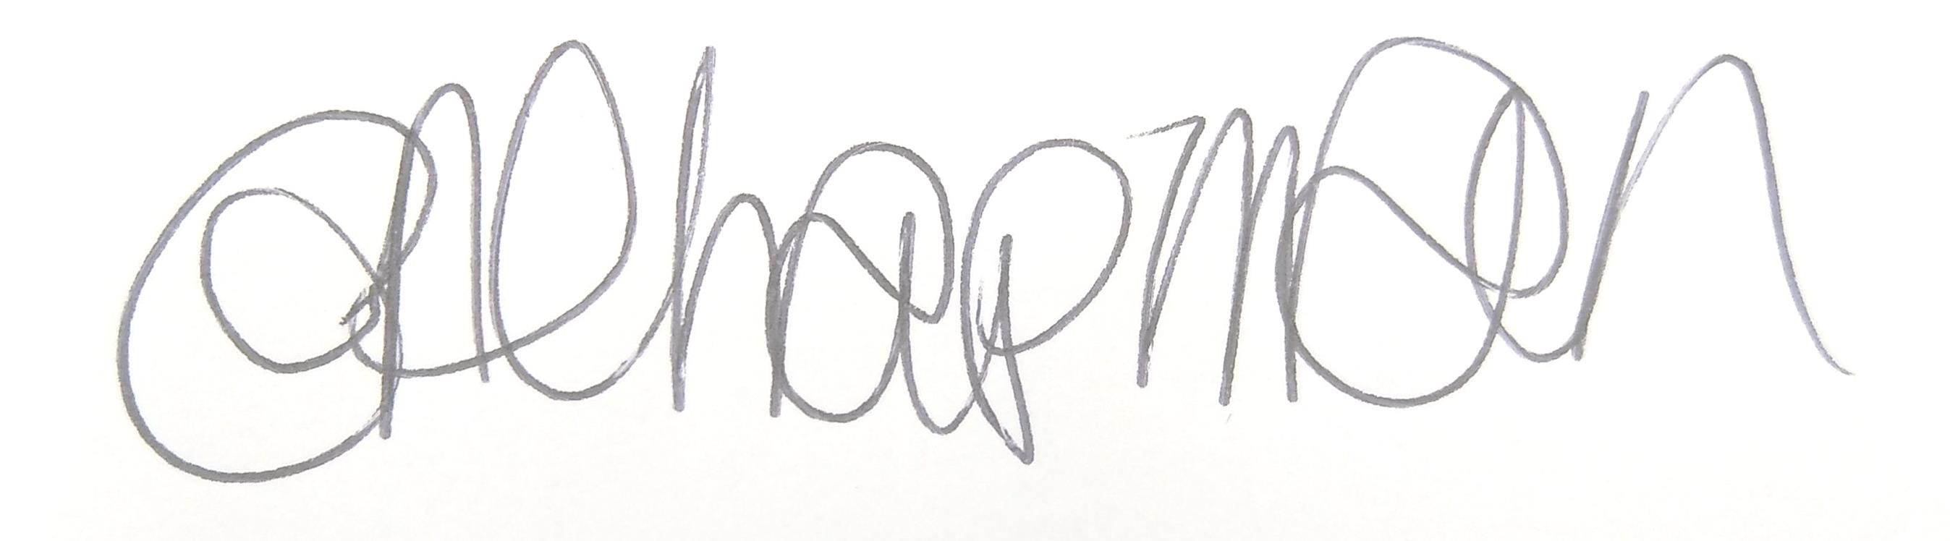

Emma Chapman
Deputy Proper Officer

AGENDA

1. Apologies: To receive and note any apologies.

2. Declarations of Interest: To receive any declarations of interest relating to matters on the agenda.

3. Exclusion of Press and Public: To consider whether there are any agenda items during consideration of which the press and public should be excluded.

4. Public Question Time: Residents are invited to give their views and question the Parish Council on issues on this agenda, or raise issues for future consideration at the discretion of the Chair. This session will last no longer than 20 minutes.

5. Minutes of the last meeting
To receive the minutes of the meeting on 12th June 2023 and affirm them as a true record.

6. Projects and Resolutions
Committee to note the report from officers with regards to projects and resolutions.

7. Planning Applications
To consider the following planning applications received from Cumberland Council.

The committee will consider planning applications received and published by local planning authorities up to the date of the meeting. Where the publication of the application is after the initial publication of the agenda, items will be added up to the day of the meeting. A full list of applications likely to be considered can be obtained by checking the local planning authority websites.

No. | Reference No. | Address | Description | Deadline for comment
A* | VAR/2023/0022 | 322 Moss Bay Road, Workington, CA14 1AF | Variation to approved application FUL/2023/0006 condition 6 (parking on forecourt) | 12/07/2023
B | FUL/2023/0121 | Land to NE St Andrews Road, Stainburn, Workington | 16 Residential dwellings | 04/07/2023
C | FUL/2023/0122 | Central Car park, Workington, CA14 3BG | Proposal of a new Community Diagnostics Hub | 04/07/2023
D | FUL/2023/0108 | Land off Moorclose Road, Workington, CA14 5BF | To develop a pump track on the disused piece of land | 05/07/2023
E | HOU/2023/0113 | 19 Bank Road, Workington, CA14 3YN | Re-submission of approved application HOU/2022/0123 for a proposed two storey side extension to provide additional bedroom and living accommodation | 05/07/2023
F | FUL/2023/0131 | 4, Risman Place, Workington, CA14 3DU | Installation of HVAC  (heating, ventilation and air conditioning) | 12/07/2023
G | HOU/2023/0115 | 11 Portland Square, Workington CA14 4BW | Replace roof with Buttermere slate where possible and Welsh reclaimed to rear (if Buttermere not available) | 12/07/2023

*Committee to note that planning application A appeared on the agenda for the meeting on 12th June 2023. Committee wished to see site of a noise report, however Cumberland Council have advised there is no noise report. They also said that ‘the application proposes the removal of a condition relating to the parking arrangements at the site so does not directly relate to noise.’

8. Cumberland Council Consultation – Lonsdale Terrace
Committee to consider a request from Cumberland Council to add a public footpath at Lonsdale Terrace in the parish of Workington. Deadline for comments – 7th July 2023.
9. Community Emergency Response Plan
Committee to consider creating a community emergency response plan for the Council, working with local partners.

