
Workington Town Council
Trustee of the Borough of Workington
Workington Town Council Community Centre, Princess Street,
Workington, Cumbria, CA14 2QG.
Telephone: 01900 702986
Email: office@workingtontowncouncil.gov.uk
Website: www.workingtontowncouncil.gov.uk

2nd October 2023

To Members of Development Committee:

Cllr Sean Melton (Chair) | Cllr Allan Hodgson (Vice Chair)
Cllr David Farrar | Cllr Tricia Poole
Cllr Hilary Harrington | Cllr Kate Schofield
Cllr Paul Larkin | Cllr Neil Schofield
Cllr Nath Martin | Cllr Dave Tennyson

(Copy for information only to other members of Workington Town Council)
You are summoned to a meeting of Workington Town Council’s Development Committee on Monday 9th October at 7pm.
The meeting will be held at the Workington Town Council Community Centre, Princess Street, Workington, CA14 2QG.

Yours sincerely,
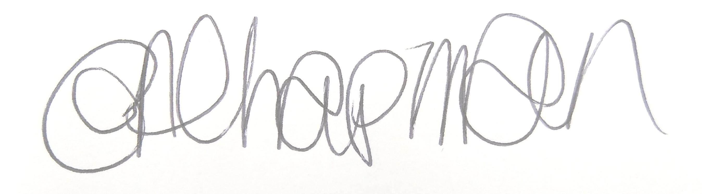

Emma Chapman
Deputy Proper Officer

AGENDA

- Apologies: To receive and note any apologies.

- Declarations of Interest: To receive any declarations of interest relating to matters which appear on this agenda.

- Exclusion of Press and Public: To consider any agenda items of which the press and public should be excluded.

- Public Participation: To consider any agenda items in which public participation will be permitted.

- Minutes of previous meetings: To approve the minutes of 11th September 2023 and affirm them a true record.

- Public Questions: To consider any questions from electors, of which notice has been given in accordance with Standing Order 3w.

- Questions and Statements from Members: To consider questions and statements by members of which notice has been given.

- Motions on Notice: To consider any motions from members of which notice has been given.

- Planning Applications: To consider the following planning applications received from Cumberland Council.

The committee will consider planning applications received and published by local planning authorities up to the date of the meeting. Where the publication of the application is after the initial publication of the agenda, items will be added up to the day of the meeting. A full list of applications likely to be considered can be obtained by checking the local planning authority website - https://cumberlandcouncil.my.site.com/pr3/s/register-view?c__r=Arcus_BE_Public_Register

No. | Reference No. | Address | Description | Deadline for comment
A | FUL/2023/0122 | Central Car Park, Workington, CA14 3BG | Proposal of a new Community Diagnostics Hub - updated | 10/10/2023
B | HOU/2023/0155 | 31 St Andrews Road, Stainburn, Workington CA14 1YY | Demolition of existing garage and build new two storey side extension | 24/10/2023
C | VAR/2023/0032 | 7 Everest Mount, Workington, CA14 5BY | Variation of condition 2 on application HOU/2022/0118 | 26/10/2023

- Previous Application Responses
Committee to note the outcome of previous applications:
No. | Reference No. | Address | Description | Outcome
A | HOU/2023/0107 | 21, Ellerbeck Lane, Workington CA14 4HE | Convert an existing single storey dwelling into a two-storey property with a first-floor extension and single storey rear extension | Granted
B | FUL/2023/0131 | 4, Risman Place, Workington, CA14 3DU | Installation of HVAC | Granted
C | HOU/2023/0138 | 102 Moorclose Road, Salterbeck, Workington, CA14 5LG | Lift side garage roof height, extend garage forward and add porch extension | Granted
D | WTPO/2023/0027 | 20 Moore Way, High Harrington, Workington, CA14 4NB | Works to Trees | Granted
E | HOU/2023/0139 | 35 Ullswater Avenue, Workington, Workington, CA14 3LB | Proposed 2 storey side extension to provide a garage with bedroom | Granted
F | HOU/2023/0144 | 19A Brow Top, Workington, CA14 2DP | Replacement of 8 wooden windows with white uPVC and 1 set of wooden French doors (at the rear) with white uPVC | Granted
G | HOU/2023/0113 | 19 Bank Road, Workington, CA14 3YN | Re-submission of approved application HOU/2022/0123 for a proposed two storey side extension to provide additional bedroom and living accommodation | Granted
H | FUL/2023/0175 | Workington Academy, Stainburn Road, Workington, CA14 4EB | External Freestanding Canopy | Granted

- Levelling Up Development Report
Committee to consider and note the Levelling Up Development report – attached.

- Council Community Emergency Response Plan
Committee to consider developing a community emergency response plan for the council, working with local partners and organisations.

- Net Zero Impacts for Cumbria / Cumbria Carbon Strategy
Committee to consider the report and agree a response.

- Communications Installation – Harrington
Committee to consider a consultation letter from Cellnex.

