
Workington Town Council
Trustee of the Borough of Workington
Workington Town Council Community Centre, Princess Street,
Workington, Cumbria, CA14 2QG.
Telephone: 01900 702986
Email: office@workingtontowncouncil.gov.uk
Website: www.workingtontowncouncil.gov.uk

13th June 2023 v2
To Members of the Culture & Community Committee:
Cllr Ellie Wood (Chair) | Cllr David Farrar (Vice Chair)
Cllr Nath Martin | Cllr Joan Wright
Cllr Barbara Cannon | Cllr Susan Martin
Cllr Sue Fryer | Cllr Kate Schofield
Cllr Jackie Kirkbride | Cllr Tricia Poole

(Copy for information only to other members of Workington Town Council)
You are summoned to a meeting of Workington Town Council Culture & Community on Wednesday, 14th June 2023 at 7pm.
The meeting will be held at the Workington Town Council Community Centre, Princess Street, Workington, CA14 2QG.

Yours faithfully

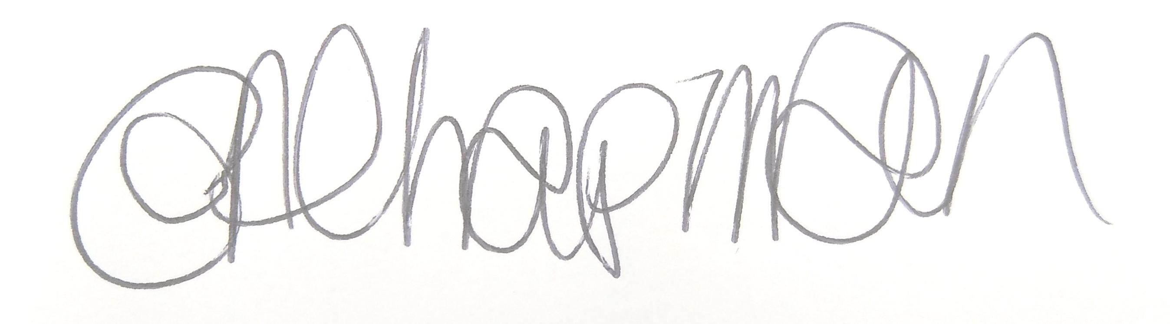

Emma Chapman
Deputy Proper Officer

AGENDA
- Apologies
To receive and note any apologies.

- Declarations of Interest
To receive any declarations of interest relating to matters which appear on this agenda, but which have not been previously declared on members’ declarations of pecuniary interest and other interests.

- Exclusion of Press and Public (Public Bodies Admission to Meetings Act 1960)
To consider whether there are any agenda items during consideration of which the press and public should be excluded.

- Minutes of the previous meeting
To note the minutes from the 7th March 2023 and affirm them a true record.

- Culture & Community Budget
- To review the Culture and Community budget YTD
- To note income of £8350 from National Lottery Community Fund for Reach Out
- To agree to pay for Armed Forces day refreshments £300 from the Cultural commissions budget line

- Events 2023
To note a report from the Events team with updates to events planned for the rest of 2023.

- Christmas Lights
To consider options for the location of the Christmas light switch on main stage:

Cumberland Council have advised that it is highly likely that they are going to need to use Marks and Spencer’s car park as their compound for the Ramsay Brow project, meaning it will not be available to host the main stage for the Christmas Light switch on.

Therefore Committee is to consider 2 alternative options:
- Main stage located outside The Entertainer / Bensons for Beds as done in 2021. This worked very well. Market stalls would be removed from this area and located elsewhere in the town to allow maximum space for spectators and there is no parade this year.
- Close off Murray Road and Finkle Street and have the main stage at the junction to the two roads. Note: this location historically has generated a lot of complaints from store owners and taxi drivers. It also means no set up can take place the day before thus resulting in Officers having to be on site at 4-5am making it an extremely long day. There would also be the added cost of a road closure, estimated at around £2.5-£3K.

Committee to note that this will alter the agreed dressing of the Christmas light infrastructure in the town, because we won’t need to dress the area around Marks and Spencer’s until next year.
Officers will be investigating this further with the contractor to confirm the light locations for this year and will report back to committee in July.

- Grants – pre approved
Committee to note that the following grants were approved prior to this meeting by
the previous Chair of Culture given their time sensitive nature.

- Grants – to be approved
- Beckstone Primary School - £300
During the pandemic, and before I became a governor, children were given the opportunity to capture an image of themselves on a tile. These tiles have been glazed and are waiting to be displayed. I was given the task of making this happen so, a grant would assist me in this.
My vision is to create an outdoor 'art gallery' for the school. There are 2 x outdoor shelters, one of which could be turned in to an area for the children's artwork to be displayed, with the tile display being the centre piece. I have the head teachers support in this vision.
The, originally planned, location for the tiles was a wall that visitors see as they approach the school from Eadie Street. The wall was, in my opinion, not a suitable location as it was unsafe. I have taken time to make this safe but have suggested that a better idea might be to display a motif that all could see on this wall. A grant would allow us to purchase the materials required to allow a local artist to conduct the work, if we can find someone willing to support this community focused plan.
£250 materials for completing shed work
£50 art supplies

- Ashfield Infants School - £300
To be able to buy and sponsor a football strip for football team which we expect will cost £300. We are also looking for some football nets for the children to use at playtimes and after school club

- Coastal Communities - £300
Towards a fun day at Harrington Marina

- Workington Sea Cadets - £275
Purchase of a gazebo and table for use at events throughout the town to inform young people about the opportunities available to them at the unit.

- Beckstone Primary School - £300
The funding will be used for a resource called Real Love Rocks which is produced by Barnados. It is solely aimed at year 6 pupils and reinforces safe relationship practise. The main focus if the resource is to help the children with their understanding of what a safe relationship us and how to protect themselves and others. The project us a great way to help the children transition into secondary school and keep themselves safe in the wider community. It has proved highly successful over the last 9 years but it has been recently updated to reflect current issues.

- High Harrington Community Centre - £300
The grant would be used to paint the kitchen and toilets in the community centre. The ,money would go towards materials to complete the project.

Committee to note that all requested information; 3 signatures, recent statements etc. have all been received by Officers for these grant requests.

- Cultural Commissions
To consider those organisations who apply for grants regularly to be awarded a ‘Cultural Commissions’. List attached

