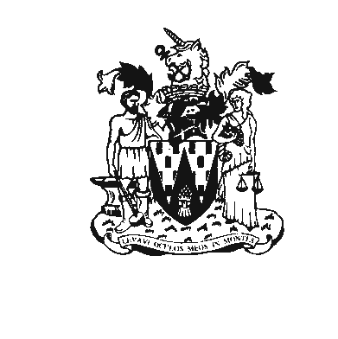
Workington Town Council
Workington Town Council Community Centre, Princess Street,
Workington, Cumbria CA14 2QG.
Telephone: 01900 702986
Email: office@workingtontowncouncil.gov.uk
Website: www.workingtontowncouncil.gov.uk

8th March 2023

Dear Councillor

You are summoned to a meeting of Workington Town Council on Monday, 13^{h} March 2023 at 7pm. The meeting will take place at the WTC Community Centre, Princess Street, Workington.

Yours faithfully

CGourlay

Catherine Gourlay
Town Clerk

AGENDA

1. Apologies
To receive and note any apologies.

2. Declarations of Interest
To receive any declarations of interest relating to matters which appear on this agenda, but which have not been previously declared on members’ declarations of pecuniary interest and other interests.

3. Exclusion of Press and Public (Public Bodies Admission to Meetings Act 1960)
To consider whether there are any agenda items during consideration of which the press and public should be excluded.

4. Moss Bay Development
To permit completion of the purchase of land at Moss Bay.

“Workington Town Council resolves to complete the purchase of land at Moss Bay known as the Ranch with immediate effect for the price of £150,000.00 under sections 9 and 10 of the Open Spaces Act 1906 upon the terms of the Sale Agreement submitted by Burnetts. Workington Town Council will cover the legal costs for the council WTC and the land seller. The Mayor is authorised to sign on behalf of the council the Sale Agreement and Transfer in the form submitted by Burnetts”.

