
Workington Town Council
Trustee of the Borough of Workington
Workington Town Council Community Centre, Princess Street,
Workington, Cumbria, CA14 2QG.
Telephone: 01900 702986
Email: office@workingtontowncouncil.gov.uk
Website: www.workingtontowncouncil.gov.uk

Date of issue: 30th January 2024
To Members of the Culture & Community Committee:
Cllr Ellie Wood (Chair) | Cllr David Farrar (Vice Chair)
Cllr Barbara Cannon | Cllr Susan Martin
Cllr Sue Fryer | Cllr Tricia Poole
Cllr Paul Larkin | Cllr Kate Schofield
Cllr Nath Martin | Cllr Joan Wright

(Copy for information only to other members of Workington Town Council).
You are summoned to a meeting of Workington Town Council’s Culture & Community Committee on Tuesday 6th February 2024 at 7pm.
The meeting will be held at the Workington Town Council Community Centre, Princess Street, Workington, CA14 2QG.

Yours sincerely,
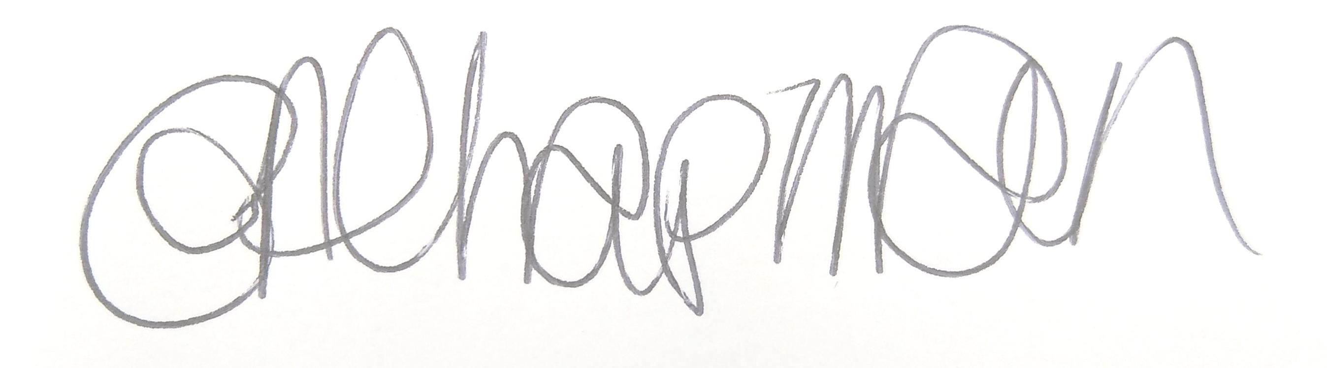

Emma Chapman
Deputy Proper Officer

AGENDA
- Apologies: To receive and note any apologies.

- Declarations of Interest: To receive any declarations of interest relating to matters on the agenda.

- Exclusion of Press and Public: To consider whether there are any agenda items during consideration of which the press and public should be excluded.

- Public Participation: To consider any agenda items in which public participation will be permitted.

- Minutes of previous meetings: To approve the minutes of 7th November 2023 and affirm them a true record.

- Public Questions: To consider any questions from electors, of which notice has been given in accordance with Standing Order 3w.

- Questions and Statements from Members: To consider questions and statements by members of which notice has been given.

- Motions on Notice: To consider any motions from members of which notice has been given.

- Budget: To note the budget monitoring report, supporting appendices and make any decisions required.

- Twinning Report: To note the report for information (report to follow).

- Carnegie Theatre Trust Reports for 2022-23 and 2023-2024: To note the reports for information.

- Carnegie Music Centre Report 2023-2024: To note the report for information.

- Christmas Lights in storage: To note the report and make any decisions required.

- Funding:
- To note funding requests approved by The Chair and Vice Chair between committee meetings;
    - NHS personalised care team (Christmas food hampers) £300
    - St Mary’s Church, Harrington (Community magazine) £300
    - Christmas in Company (Christmas day meals) £500
    - Theatre Royal (post vandalism support) £1,000
- To note that funding feedback has been received from Christmas in Company.
- To consider a funding application from Workington Heritage Group.

- New Expressions of interest for funding: To note the report, consider the new funding requests and make any decisions required.

- Events programme/budget 2024-2025: To note the programme and budget approved by Full Council, discuss any ideas committee would like Officers to investigate and make any decisions required.

