
Workington Town Council
Town Hall, Oxford Street, Workington, CA14 2RS
Telephone: 01900 702986
Email: office@workingtontowncouncil.gov.uk
Website: www.workingtontowncouncil.gov.uk

Date of issue: Tuesday 22nd October 2024.
To Members of the Culture & Community Committee:
Cllr Ellie Wood (Chair) | Cllr Susan Martin (Vice Chair)
Cllr Beth Dixon | Cllr Paul Larkin
Cllr David Farrar | Cllr Tricia Poole
Cllr Sue Fryer | Cllr Stephen Stoddart
Cllr Allan Hodgson | Cllr Joan Wright

(Copy for information only to other members of Workington Town Council).
You are summoned to a meeting of Workington Town Council’s Culture & Community Committee on Tuesday 29th October 2024 at 6.30pm.
The meeting will be held at the Workington Town Council Offices, Town Hall, Oxford Street, Workington, CA14 2QG.

Yours sincerely,
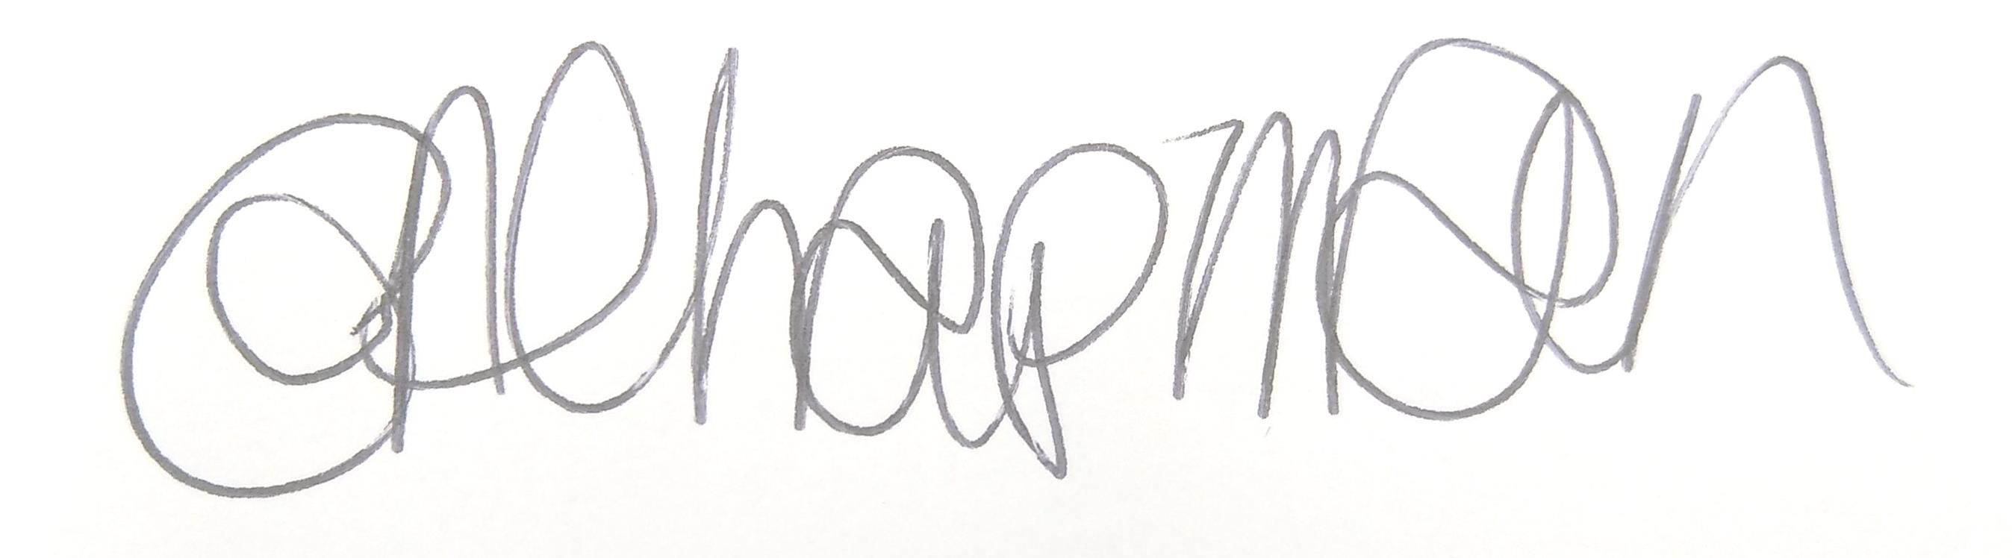

Emma Chapman
Chief Officer/RFO

AGENDA
- Absences: To note any absences.

- Declarations of Interest: To receive any declarations of interest relating to matters on the agenda.

- Exclusion of Press and Public: To consider whether there are any agenda items during consideration of which the press and public should be excluded.

- Public Participation: To consider any agenda items in which public participation will be permitted.

- Minutes of previous meetings: To approve the minutes of 17th September 2024 and affirm them a true record.

- Public Questions: To consider any questions from electors, of which notice has been given.

- Questions and Statements from Members: To consider questions and statements by members of which notice has been given.

- Motions on Notice: To consider any motions from members of which notice has been given.

- Funding/commission feedback: To note feedback from the following organisations.
- A New Hope CIC

- New funding/commission/partnership requests:
- To consider an application from Carnegie Theatre and Arts Centre
- To consider an application from Christmas in Company
- To consider an application from Harrington Youth Club
- To consider an application from TPS Netball
- To consider an application from Workington Music Festival
- To consider an application from St Mary’s Church, Harrington

- Art Exhibition and Schools Competition: Committee to note the report for information and make any decisions required.

- Budget 2024-2025:
a) To review the budget YTD and estimated spend to 31st March 2025.
b) To approve an invoice from the Twinning association

- Events Programme 2025: Committee to consider the draft events programme for 2025.

- Budget 2025-2026: Committee to consider the draft budget for 2025-2026.

